

DAYANANDA SAGAR COLLEGE OF ENGINEERING
(An Autonomous Institute affiliated to Visvesvaraya Technological University (VTU), Belagavi,
Approved by AICTE and UGC, Accredited by NAAC with ‘A’ grade & ISO 9001 – 2015 Certified Institution)
ShavigeMalleshwara Hills, Kumaraswamy Layout, Bengaluru-560 111, India

DEPARTMENT OF ELCTRONICS & COMMUNICATION ENGINEERING
(Accredited by NBA Tier 1: 2022-2025)

COURSE NAME: IDT- Innovative and Design Thinking
COURSE CODE: 1BIDTL158
A Mini Project Report on

SOLAR CHARGER FOR MOBILE PHONES

Bachelor of Engineering
in
Electronics & Communication Engineering

Submitted by

AZHAR ALI BOHRA | USN:1DS25EC058
MOHAMMED NABEEL | USN:1DS25EC163
SAMARTH THAKUR | USN: 1DS25EC225
ANIRUDH KADAM | USN: 1DS25EC041
Under the Guidance of
Prof. CHAITRA A.
Assistant Professor
Department of Electronics and Communication Engineering
DSCE, Bengaluru

VISVESVARAYA TECHNOLOGICAL UNIVERSITY
JNANASANGAMA, BELAGAVI-590018, KARNATAKA, INDIA
2025-26

DAYANANDA SAGAR COLLEGE OF ENGINEERING
(An Autonomous Institute affiliated to Visvesvaraya Technological University (VTU), Belagavi,
Approved by AICTE and UGC, Accredited by NAAC with ‘A’ grade & ISO 9001 – 2015 Certified Institution)
ShavigeMalleshwara Hills, Kumaraswamy Layout, Bengaluru-560 111, India

DEPARTMENT OF ELECTRONICS & COMMUNICATION ENGINEERING
(Accredited by NBA Tier 1: 2022-2025)



CERTIFICATE

Certified that the project report entitled “SOLAR CHARGER FOR MOBILE PHONE” carried out by AZHAR ALI BOHRA (1DS25EC058), MOHAMMED NABEEL(1DS25EC163), SAMARTH THAKUR(1DS25EC225), ANIRUDH KADAM(1DS25EC041) are a Bonafide student of DAYANANDA SAGAR COLLEGE OF ENGINEERING, an autonomous institution affiliated to VTU, Belagavi in partial fulfillment for the award of Degree of Bachelor of Electronics & Communication Engineering during the year 2025-2026. It is certified that all corrections/suggestions indicated for Internal Assessment have been incorporated in the report deposited in the departmental library. The mini project report has been approved as it satisfies the academic requirements with respect to the work prescribed for the said Degree.

Signature of the Guide  Prof. CHAITRA A.  Assistant Professor  Dept. of ECE, DSCE Bengaluru | Signature of the HOD  Dr. Shobha.K.R  Professor & Head  Dept. of ECE,DSCE  Bengaluru | Signature of the Principal  Dr. B G Prasad  Principal  DSCE, Bengaluru

Name of the Examiners  - ...........................................  - ........................................... |  | Signature with date  ..........................................  ..........................................

DAYANANDA SAGAR COLLEGE OF ENGINEERING
(An Autonomous Institute affiliated to Visvesvaraya Technological University (VTU), Belagavi,
Approved by AICTE and UGC, Accredited by NAAC with ‘A’ grade & ISO 9001 – 2015 Certified Institution)
ShavigeMalleshwara Hills, Kumaraswamy Layout, Bengaluru-560 111, India

DEPARTMENT OF ELECTRONICS & COMMUNICATION ENGINEERING
(Accredited by NBA Tier 1: 2022-2025)


DECLARATION

We, AZHAR ALI BOHRA (1DS25EC058), MOHAMMED NABEEL(1DS25EC163), SAMARTH THAKUR(1DS25EC225), ANIRUDH KADAM(1DS25EC041) respectively, hereby declare that the mini project work entitled “ Solar charger for mobile phones ” has been independently done by us under the guidance of PROF. CHAITRA A. and submitted in partial fulfillment of the requirement for the award of the degree of Bachelor of Electronics & Communication Engineering at Dayananda Sagar College of Engineering, an autonomous institution affiliated to VTU, Belagavi during the academic year 2025-2026.
We further declare that we have not submitted this report either in part or in full to any other university for the award of a
Submitted by

AZHAR ALI BOHRA | USN:1DS25EC058
MOHAMMED NABEEL | USN: 1DS25EC163
SAMARTH THAKUR | USN: 1DS25EC225
ANIRUDH KADAM | USN: 1DS25EC041

ACKNOWLEDGEMENT
The satisfaction and euphoria accompanying the successful completion of any task would be incomplete without the mention of people who made it possible and under constant guidance and encouragement the task was completed. We sincerely thank the Management of Dayananda Sagar College of Engineering, Bengaluru.
We express our sincere regards and thanks to Dr. B G Prasad, Principal, Dayananda Sagar College of Engineering, Bengaluru. His constant encouragement guidance and valuable support have been an immense help in realizing this project.
We express our sincere regards and thanks to Dr. Shobha.K.R, Professor & Head, Department of Electronics & Communication Engineering, Dayananda Sagar College of Engineering, Bengaluru. Her incessant encouragement guidance and valuable technical support have been an immense help in realizing this project. Her guidance gave us the environment to enhance our knowledge, and skills and to reach the pinnacle with sheer determination, dedication, and hard work.
We would like to express profound gratitude to our Project guide Prof. Chaitra A. ,Assistant Professor, Department of Electronics & Communication Engineering, Dayananda Sagar College of Engineering, Bengaluru who has encouraged us throughout the project. Her moral support enabled us to complete our project work successfully.
We express our sincere thanks to Project coordinators of the Department of Electronics and Communication Engineering for their continues support and guidance. We thank all teaching and non-teaching staff of the Department of Electronics and Communication Engineering for their kind and constant support throughout the academic Journey

ABSTRACT
The Solar Charger project is designed to explore the practical application of renewable energy by developing a system that efficiently converts solar energy into electrical power for charging electronic devices. With the increasing demand for portable energy and the rapid depletion of conventional energy resources, the use of solar power has become a sustainable and environmentally friendly alternative. This project emphasizes the utilization of solar energy as a clean, renewable, and widely available source to meet everyday power requirements.
The core component of the solar charger is the photovoltaic (PV) panel, which captures sunlight and converts it into direct current (DC) electricity through the photovoltaic effect. The generated electrical energy is then processed through a charge controller circuit to regulate voltage and current, ensuring safe and efficient charging of connected batteries or devices. The system is designed to provide a stable output suitable for commonly used electronic devices such as mobile phones, power banks, and small electronic gadgets.
One of the primary objectives of this project is to demonstrate the feasibility of solar-powered charging systems in reducing dependency on grid electricity and fossil fuels. By using solar energy, the project contributes to lowering carbon emissions and promoting sustainable development. The solar charger is particularly beneficial in remote and rural areas where access to reliable electricity is limited, as well as during emergency situations and outdoor activities such as camping, trekking, and disaster relief operations.
The project also focuses on simplicity, cost-effectiveness, and portability. Readily available components are used to make the system affordable and easy to replicate. The compact design allows the charger to be easily transported and deployed in various environments. Additionally, the project highlights the importance of energy management and efficiency by minimizing power losses and optimizing energy conversion.
Overall, the Solar Charger project serves as a practical demonstration of how renewable energy technologies can be integrated into daily life. It provides valuable insights into solar power generation, and power regulation techniques. This project not only enhances technical understanding but also raises awareness about the importance of adopting clean energy solutions to address global energy challenges. By promoting the use of solar energy, the project encourages sustainable practices and supports the transition toward a greener and more energy-efficient future.

Table of Contents

ACKNOWLEDGMENT.......................................................................................iiiAABSTRACT............................................................................................................ iv
LIST OF FIGURES………………………….…………………………………… vi
- INTRODUCTION………………………………………………………………1
1.1 Overview
1.2 ProblemStatement
1.3 Objectives
1.4 Motivation
- LITERATURE SURVEY…………………………………………...….3
- METHODOLOGY…………………..……………………………………….…4
  - Block diagram and working principle of proposed system
  - Circuit diagram of Proposed system
  - Hardware Design

- RESULTS AND DISCUSSIONS ………………………...………..........8
  - Data Collection: Present raw data collected during testing.
- APPLICATION, ADVANTAGES& LIMITATION……..……………..10
5.1 Application
5.2 Advantages
5.3 Limitation
- CONCLUSIONANDFUTUREOUTLOOK……………………...….11
6.1 Conclusion
6.2 Future Scope

LIST OF FIGURES
Fig. no. | Fig. Caption | Page no.
3.1 | Block diagram for Solar Charger for Mobile Phones | 5
3.2 | Circuit diagram | 6
4.1 | Unregulated power from solar panels | 8
4.2 | Regulated output voltage | 9

CHAPTER 1
INTRODUCTION
1.1 Overview
Solar chargers play a vital role in promoting sustainable and eco-friendly energy solutions. Since solar energy is clean, renewable, and abundantly available, the use of solar chargers helps reduce dependence on conventional electricity generated from fossil fuels. This contributes to lower carbon emissions and supports environmental conservation. Solar chargers are especially beneficial in remote and rural areas where access to grid electricity is limited or unreliable. They are also useful during emergencies, natural disasters, and outdoor activities such as camping and trekking.
A typical solar charger consists of several key components, including a solar panel, charge controller and output interface. The solar panel captures sunlight and converts it into electrical energy. The charge controller regulates voltage and current to protect the connected devices from overcharging or short circuits.
With advancements in solar technology, modern solar chargers have become more efficient, portable, and cost-effective. They offer a practical solution for meeting everyday energy needs while encouraging the adoption of renewable energy and supporting a sustainable future.
1.2 Problem Statement
- In today’s world, the use of portable electronic devices such as smartphones, tablets, cameras, and GPS units has become essential for communication, navigation, and daily activities.
- However, keeping these devices charged remains a major challenge, especially in areas with limited or unreliable access to electricity.
- Traditional chargers and power banks depend heavily on grid power, making them ineffective during travel, outdoor activities, emergencies, or in rural regions with poor electrical infrastructure.
- This creates a significant dependency on non-renewable energy sources and contributes to environmental issues such as increased carbon emissions.

1.3 Objective

The main objective of the solar charger project is to design and develop an efficient, reliable, and portable charging system that utilizes solar energy as a clean and renewable power source. As the demand for mobile electronic devices continues to grow, the dependency on traditional grid-based electricity has increased, creating challenges for users in remote areas, during travel, or in regions with unstable power supply. This project aims to address these issues by creating a sustainable charging alternative that operates independently of conventional electricity.
The solar charger will focus on maximizing the conversion of sunlight into usable electrical energy through photovoltaic panels, while ensuring stable and safe output for charging a variety of devices such as smartphones, tablets, and small portable electronics. Another key objective is to design the system to be lightweight, durable, and user-friendly, making it suitable for outdoor activities and emergency situations. The project also emphasizes cost-effectiveness, enabling broader accessibility, especially in rural or underdeveloped regions where power availability is limited.
Ultimately, the objective is to provide a practical, eco-friendly solution that reduces reliance on non-renewable energy sources, encourages the use of sustainable technologies, and supports a greener future through the integration of solar power into everyday life.
1.4 Motivation
The increasing reliance on portable electronic devices such as smartphones has made reliable access to electrical power a daily necessity. In many situations,including rural areas, outdoor activities, emergencies, or regions with unreliable electricit, the rising demand for energy emphasizes the need for renewable and sustainable sources. Solar energy, being abundant, clean, and renewable, offers an effective solution for small-scale applications such as mobile phone charging. This project focuses on designing a simple, low-cost, and efficient solar-powered USB charging system suitable for real-world, off-grid conditions.During the development process, commonly available power bank modules were evaluated and found to be inefficient for direct solar input due to added components such as batteries, which increase complexity and power loss. This led to a direct design approach using a DC buck converter to regulate the solar panel output and deliver a stable 5 V USB supply.The objectives of this project are to:
- Design an efficient direct solar-to-USB charging system with minimal power loss
- Gain practical experience with DC-DC converters, voltage regulation, and USB charging standards
- Promote renewable energy through a functional and educational hardware project
Overall, this project demonstrates that a carefully designed solar-powered USB charger can be both practical and efficient while serving as a valuable learning platform in renewable energy systems and power electronics.
CHAPTER 2
LITERATURE SURVEY
The development of portable charging systems using renewable energy sources has been widely studied, with solar-powered mobile chargers receiving significant attention due to their practicality and environmental benefits. Several researchers and designers have proposed different architectures for converting solar energy into a stable power source suitable for charging portable electronic devices[1][2][4][6].
Early solar charging systems primarily relied on linear voltage regulators to step down solar panel voltage to the required levels[1][4]. While simple in design, linear regulators were found to be inefficient due to high power dissipation, especially when the difference between input and output voltage is large[5]. This limitation led to the increased adoption of DC-DC switching converters[2], particularly buck and buck-boost converters, which offer higher efficiency and improved power utilization[6].
Many studies have explored the use of power bank modules in solar charging applications. These modules typically integrate a boost converter to provide a regulated 5 V USB output[6]. Research shows that while power bank modules are convenient and compact[2], they are optimized for stable input sources such as wall adapters rather than variable solar inputs. The requirement of an intermediate battery and multiple power conversion stages results in increased energy loss and reduced overall system efficiency.Several works have proposed solar charging systems with energy storage, where the solar panel charges a battery during daylight hours and the stored energy is later used to power USB devices[2][6]. Although this approach improves availability during low-light conditions, it introduces additional challenges such as battery management, charging inefficiencies, thermal issues, and reduced system lifespan if not properly controlled.
Recent literature emphasizes direct solar-to-load architectures, where the solar panel output is regulated using a high-efficiency DC-DC converter and directly supplied to the load. Such systems reduce component count, improve efficiency, and simplify design. However, these designs require careful voltage regulation, current handling, and output stabilization to meet USB charging requirements and prevent device disconnection due to voltage fluctuations.Studies on USB charging standards highlight the importance of correct voltage levels and data-line configurations (D+ and D−) to enable proper current negotiation and ensure compatibility with modern smartphones[6]. Improper signaling can result in slow charging or device rejection, even when sufficient power is available.
Overall, the literature indicates that while battery-based solar charging systems offer energy storage benefits, direct buck-converter-based USB charging systems provide a simpler, more efficient, and cost-effective solution for charging applications. This project builds upon these findings by implementing a direct solar-powered USB charger using a buck converter.
CHAPTER 3
METHODOLOGY
3.1 Block diagram and working principle of proposed system
The proposed system operates on the principle of converting solar energy into a regulated DC voltage suitable for charging USB-powered devices such as smartphones. The system primarily consists of a solar panel, a DC buck converter, filtering components, and a USB-A output connector.
When the solar panel is exposed to sunlight, it generates a DC voltage that varies with solar intensity. Under normal operating conditions, the panel produces approximately 13–14 V, which is unsuitable for directly charging USB devices. This variable high-voltage DC output is therefore fed into a DC buck converter.
The buck converter functions as a step-down switching regulator, reducing the solar panel voltage to a stable output of approximately 5.1 V. By using energy storage elements such as capacitors, the buck converter achieves efficient voltage regulation with minimal power loss. The output voltage is adjusted to remain within the acceptable USB charging range, ensuring device safety and compatibility.
To improve output stability and reduce voltage ripple caused by solar fluctuations and load variations, a filtering capacitor is connected across the buck converter output. This capacitor acts as an energy buffer, smoothing transient drops in voltage when the connected device draws current during charging.
The regulated 5 V output from the buck converter is then supplied directly to a USB-A connector. The power lines (VBUS and GND) provide the necessary charging voltage, while the USB data lines (D+ and D−) are configured to signal a dedicated charging port, enabling the connected device to draw appropriate charging current.
When a mobile device is connected, it detects the stable 5 V supply at the USB port and begins charging. The charging current is automatically drawn based on the device’s requirements and the available solar power. As long as sufficient sunlight is present, the system continuously regulates the output voltage and safely supplies power to the device.
Thus, the proposed system efficiently converts solar energy into usable electrical power for USB charging applications without the need for intermediate battery storage, reducing system complexity, improving efficiency, and enhancing reliability during daytime operation

Block diagram-
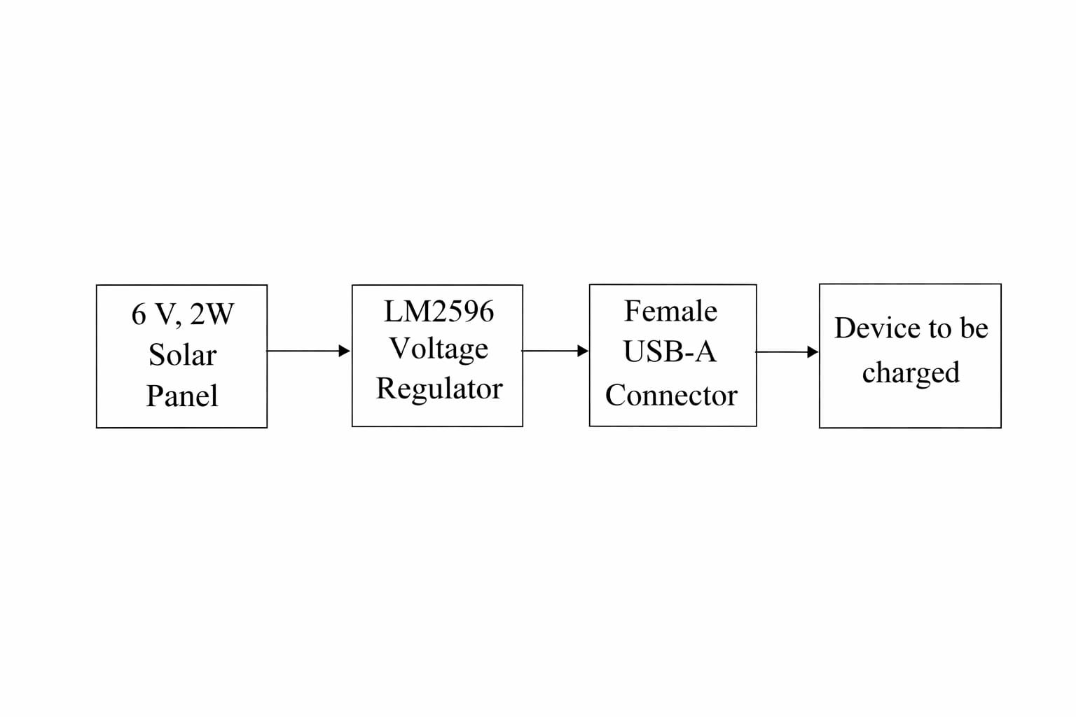Fig 3.1 Block diagram for Solar Charger for Mobile Phones

3.2 Circuit diagram of Proposed system
The circuit diagram of the proposed system represents the interconnection of the main hardware components used to implement the solar-powered USB charging system. The system is designed to convert the variable DC output of a solar panel into a regulated 5 V supply suitable for USB-powered devices.
The solar panel forms the input stage of the circuit and provides a DC voltage of approximately 13–14 V under normal sunlight conditions. The positive and negative terminals of the solar panel are connected to the input terminals of a DC buck converter. The buck converter is configured to step down the higher input voltage to a stable output voltage of approximately 5.1 V.
At the output of the buck converter, a filtering capacitor is connected across the positive and ground terminals. This capacitor reduces voltage ripple and helps maintain output stability during sudden load changes when a mobile device is connected or disconnected.
The regulated output from the buck converter is then connected to a USB-A female connector. The +5 V output is connected to the VBUS pin of the USB connector, while the ground is connected to the GND pin. The USB data pins (D+ and D−) are either shorted together or configured using appropriate resistors to indicate a dedicated charging port, enabling the connected device to draw sufficient charging current.
All components share a common ground reference to ensure proper voltage regulation and reliable operation. The circuit does not include a battery or power bank module, thereby eliminating unnecessary power conversion stages and improving overall system efficiency.
The circuit diagram thus illustrates a simple, efficient, and reliable solar-powered USB charging system using a DC buck converter as the core voltage regulation element.
.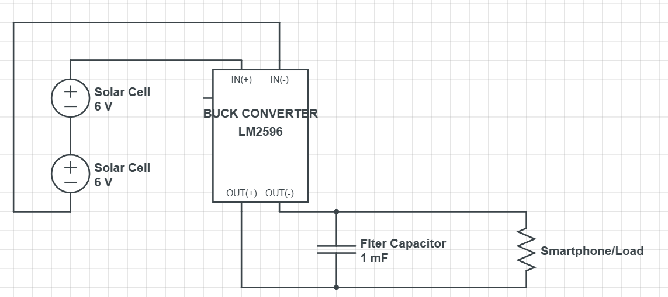
Fig. 3.2 Circuit diagram

3.3 Hardware design
The hardware design of the proposed solar-powered USB charging system focuses on simplicity, efficiency, and reliability. The system is designed to convert the variable DC output of a solar panel into a stable 5 V supply suitable for charging USB-powered devices. The major hardware components used in the design include a solar panel, a DC buck converter, filtering components, and a USB-A output connector.
3.3.1 Solar Panel
The solar panel serves as the primary energy source of the system. It converts solar energy into electrical energy and provides a DC output voltage of approximately 13–14 V under standard sunlight conditions. The panel is selected based on its ability to supply sufficient voltage and current required for charging mobile devices during daylight hours. The positive and negative terminals of the solar panel are connected directly to the input terminals of the buck converter.
3.3.2 DC Buck Converter
The DC buck converter is the core component of the hardware design. Its primary function is to step down the higher and variable DC voltage from the solar panel to a stable voltage suitable for USB charging. The buck converter operates using high-frequency switching techniques to achieve efficient voltage regulation with minimal power loss.
The output voltage of the buck converter is adjusted to approximately 5.1 V to comply with USB charging standards and to compensate for voltage drops under load. The converter also provides inherent current limiting and protection features, ensuring safe operation of the connected devices.
3.3.3 Output Filtering and Stabilization
To minimize voltage ripple and transient fluctuations caused by changes in sunlight intensity and load conditions, an electrolytic capacitor is connected across the output terminals of the buck converter. This capacitor acts as an energy storage element, improving output voltage stability and preventing sudden voltage drops when a mobile device begins charging.
Additional decoupling capacitors may be used to further reduce noise and improve system reliability.
3.3.4 USB-A Output Connector
A USB-A female connector is used as the output interface for charging mobile devices. The regulated 5 V output from the buck converter is connected to the VBUS pin of the USB connector, while the ground is connected to the GND pin. The data pins (D+ and D−) are configured to indicate a dedicated charging port, allowing the connected device to draw adequate charging current.
The USB connector provides a standardized and widely compatible interface, making the system suitable for charging a wide range of USB-powered devices.
CHAPTER 4
RESULTS AND DISCUSSIONS
4.1 Data Collection
During the testing phase of the proposed system, voltage measurements were carried out at different stages of the circuit to verify proper operation and performance. The solar panel used in the system was rated at 6 V and 2 W. Under good sunlight conditions, the open-circuit voltage of the solar panel was measured using a digital multimeter and was found to be approximately 14.4V.
The output of the solar panel was then fed into a DC buck converter. The buck converter output voltage was adjusted and measured to ensure compatibility with USB charging standards. The measured output voltage of the buck converter was observed to be stable within the range of 5.0 V to 5.15 V under normal operating conditions.
The output from buck converter is then fed (5-5.15V) to USB-A connector(connected parallely with a capacitor as a filter) which is connected to the required mobile phone/device All voltage measurements were taken using a digital multimeter under steady sunlight conditions.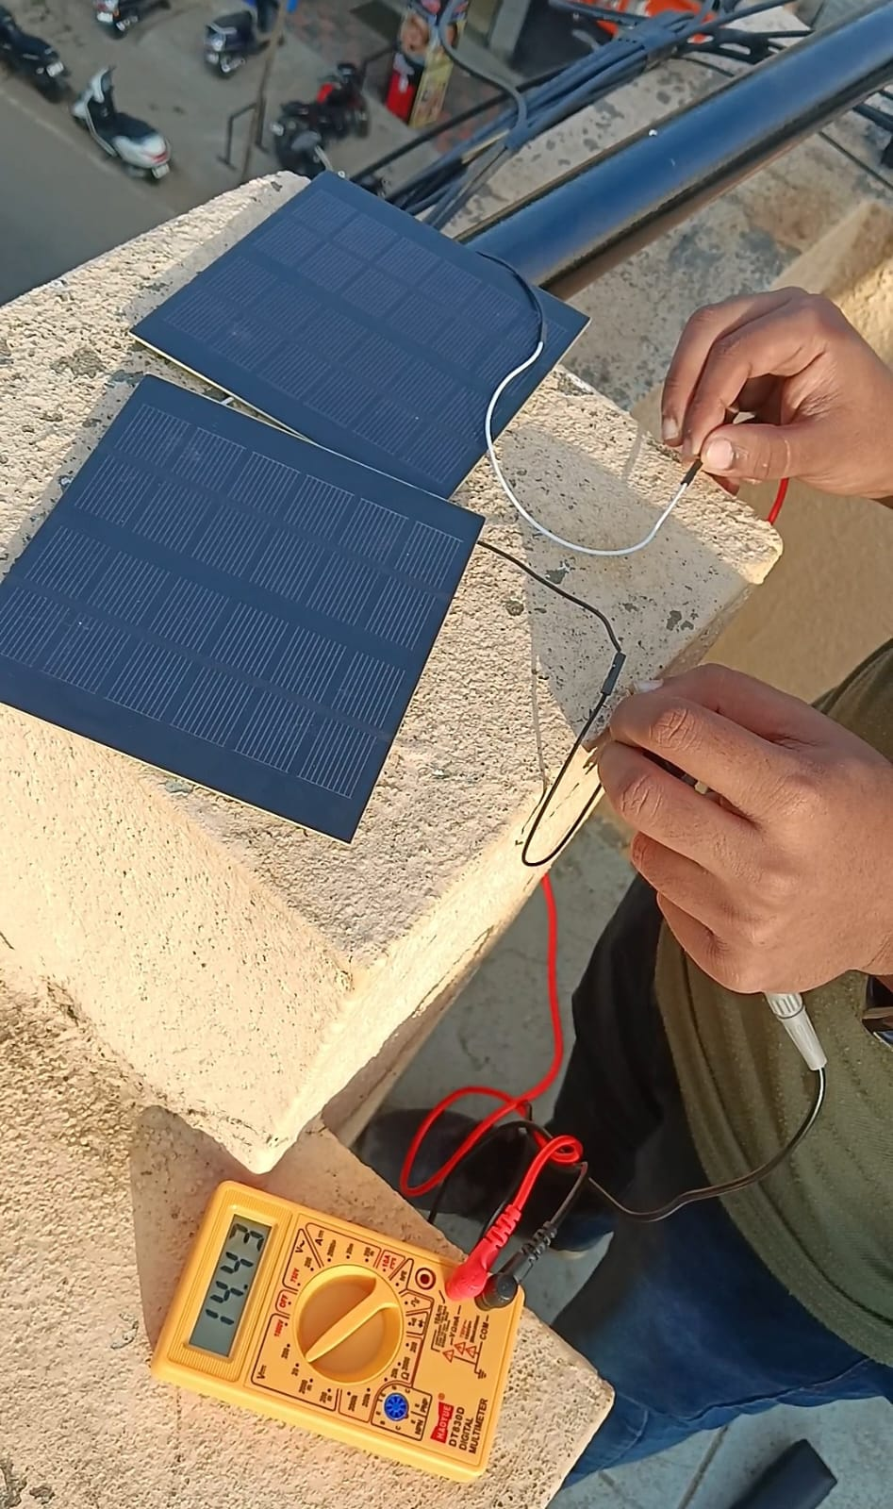

Fig 4.1 Unregulated power from solar panels
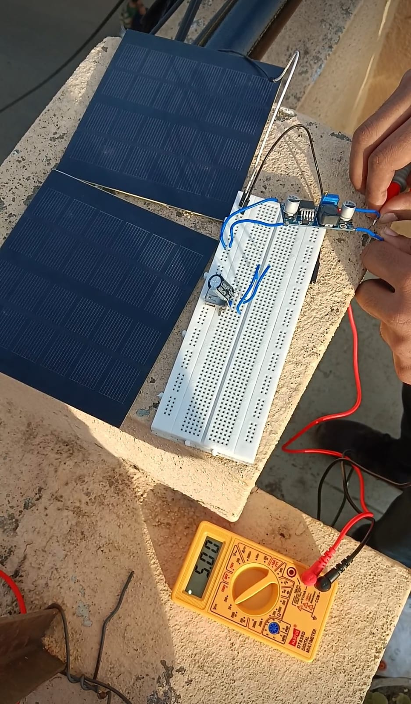

Fig. 4.2 Regulated output voltage

CHAPTER 5
APPLICATION, ADVANTAGES& LIMITATION

5.1 Applications
The proposed solar-powered USB charging system can be used to charge mobile phones and other USB-powered devices in areas where conventional electricity is unavailable or unreliable, such as rural and off-grid locations. It is particularly useful during emergency situations and power outages, where maintaining communication is essential. Owing to its portability and use of renewable energy, the system is well suited for outdoor activities like camping, trekking, and fieldwork. The project also serves as an educational platform for understanding solar energy utilization, DC-DC voltage regulation, and practical power electronics. In addition, by relying on solar power, the system promotes environmentally friendly energy usage and can be used to power small USB-based devices such as LED lights and other low-power electronics..

5.2 Advantages
The proposed solar-powered USB charging system offers several advantages, including simple circuit design, low cost, and high efficiency due to the use of a DC buck converter instead of multiple power conversion stages. By eliminating the need for batteries and power bank modules, the system reduces energy losses, component count, and maintenance requirements. It utilizes renewable solar energy, making it environmentally friendly and suitable for off-grid applications. The system is portable, easy to implement, and compatible with a wide range of USB-powered devices, making it a practical and reliable solution for daytime charging needs and educational demonstrations.

5.3 Limitations
The proposed solar-powered USB charging system has certain limitations, primarily due to its dependence on sunlight availability, which restricts its operation to daytime and clear weather conditions. Variations in solar intensity can affect charging speed and may cause unstable output if sunlight is insufficient. Since the system does not include battery storage, it cannot provide power during night-time or low-light conditions. Additionally, the charging current is limited by the capacity of the solar panel and the buck converter, making the system unsuitable for fast charging or high-power devices.

CHAPTER 6
CONCLUSION AND FUTURE OUTLOOK
6.1 Conclusion
The solar-powered USB charging system developed in this project demonstrates an efficient and practical method of converting solar energy into a regulated 5 V supply suitable for charging USB-powered devices. By using a DC buck converter to directly regulate the solar panel output, the system avoids the complexity and inefficiency associated with power bank modules and intermediate battery storage. The design is simple, cost-effective, and environmentally friendly, making it suitable for off-grid and emergency applications. Overall, the project highlights the effective use of renewable energy and power electronics principles to create a reliable and sustainable mobile charging solution.

6.2 Future Scope
The future scope of this project includes the integration of energy storage elements such as rechargeable batteries or supercapacitors to enable charging during night-time and low-light conditions. Advanced solar charge controllers with maximum power point tracking (MPPT) can be incorporated to improve energy harvesting efficiency under varying sunlight conditions. The system can also be enhanced by adding support for fast-charging standards and multiple USB outputs to charge more than one device simultaneously. Additionally, improvements in enclosure design, portability, and weatherproofing can make the system more suitable for real-world outdoor and commercial applications.

REFERENCE

[1] Amit S. Bhala, Kilme R Marak, Shilpa N. Lanjulkar, Puja K Kale, "Solar mobile phone charger",IJCRT,International Journal of Creative Research Thoughts,vol.6, issue 1,Feb,2018,pp.1498-1508,
[2] C. Schuss and T. Rahkonen, "Photovoltaic (PV) energy as recharge source for portable devices such as mobile phones," 2012 12th Conference of Open Innovations Association (FRUCT), Oulu, Finland, 2012, pp. 1-9, doi: 10.23919/FRUCT.2012.8122095.
[3] https://youtu.be/YSRs3PuYT_k?si=IT8ta8i-KBWX4E7V “Solar cells - working | Semiconductors | Physics | Khan Academy”
[4] K. S, G. N. P, Y. T. S and R. S, "Solar-Powered Mobile Phone Charger Tapping into Sustainable Energy," 2023 International Conference on System, Computation, Automation and Networking (ICSCAN), PUDUCHERRY, India, 2023, pp. 1-6, doi: 10.1109/ICSCAN58655.2023.10395217.

[5] A. Barad, S. Tungar, N. Sangle, K. Bharambe and D. P. Kadam, "Solar panel based multi-mobile charger with LED illumination," 2017 International Conference on Innovations in Information, Embedded and Communication Systems (ICIIECS), Coimbatore, India, 2017, pp. 1-4, doi: 10.1109/ICIIECS.2017.8276052.

[6]N. K. Raghavendra and K. Padmavathi, "Solar Charge Controller for Lithium-Ion Battery," 2018 IEEE International Conference on Power Electronics, Drives and Energy Systems (PEDES), Chennai, India, 2018, pp. 1-5, doi: 10.1109/PEDES.2018.8707743.

